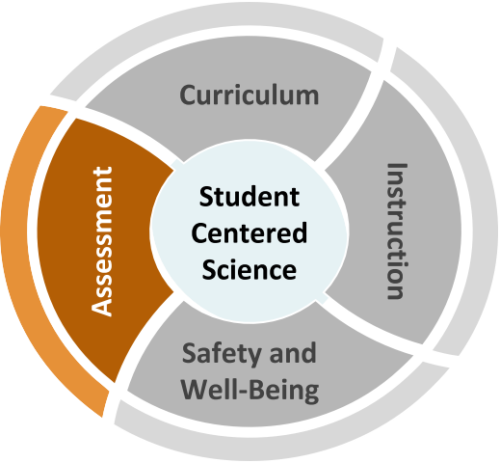
Science Assessment
Back-to-School Considerations
How will we know what students know and can do when going back-to-school with different models?

Schools need to decide what role formative practices and tasks, interim measures, and summative checks play in seamlessly revealing evidence of student progress of 3D learning along a continuum.
Tensions We Are Navigating
- Assessments can provide evidence of student learning; however, students must feel comfortable and safe sharing their work, skills, and knowledge. Create asset-based and identity-safe systems that support students in being comfortable sharing the evidence of their learning fully and in rich detail.

- There are calls for diagnosing student understanding through immediate, extensive, and standardized-type testing; however, assessments should be an integrated part of classroom teaching and learning with the goal of supporting the development of
grade-level practices and concepts (see vignette on next page).
- Teachers use classroom assessment practices that promote ongoing conversations about learning, and provide students with actionable steps to grow agency and ownership of learning; however, teachers may need support in adapting these strategies for online or blended learning.

- Organizations such as Boards of Education and legislatures are calling for data; however, such data may not serve student learning and many assessments privilege only one way of knowing that is not representative of all that students know and can do.

Recommended Reflection Questions
Use these questions with your PLC to examine current practice and engage in forward planning.

    - How will you use formative assessments to understand student skills and knowledge, inform instruction, and scaffold learning opportunities? How will you use assessments to inform equitable access to on-grade learning?
    - What assessment practices can be discarded, particularly those that do not inform learning? How can mandatory assessments be meaningfully implemented and interpreted without “teaching to the test”?
    - How might evidence of learning collected differ for face-to-face, blended, or online learning? What instructional resources can support student learning in these modes, depending on where you determine more focus is needed?

Science Assessment
Where can we start?
Administrators
Collaborate to identify priority three- dimensional learning goals and how assessments support these goals. Revise assessments that are convenient (e.g. multiple choice) but are not three-dimensional.
★ Why Formative Assessments Matter
★ Helping Students Understand What a Test Is and Is Not
★ Science Assessment Task Screeners
★ CCSSO Assessment Considerations

Teachers
Utilize a coherent system of assessment to gauge science learning and student agency. Scaffold formative assessments to support students in making their ideas explicit as they develop higher-level explanations
★ Steps to designing a 3D Assessment
★ Using 3D Interim Assessments
★ What Can I Learn from Students’ Work?

Students, Families, and Communities Encourage students to engage and share at home in meaningful and authentic ways.
★ Learning in Places
★ Science: It’s a Family Affair

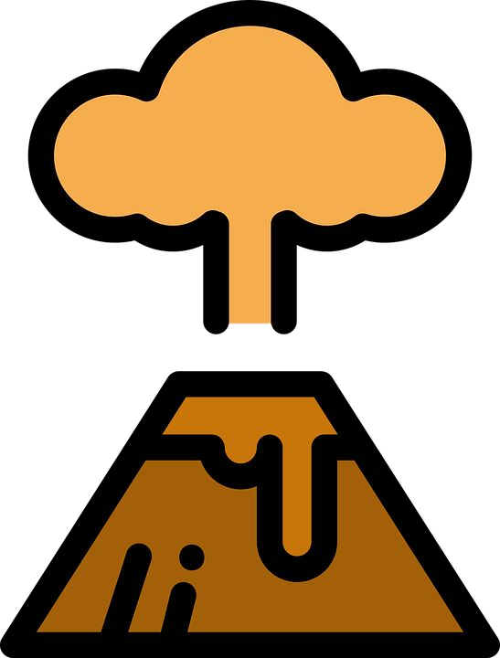
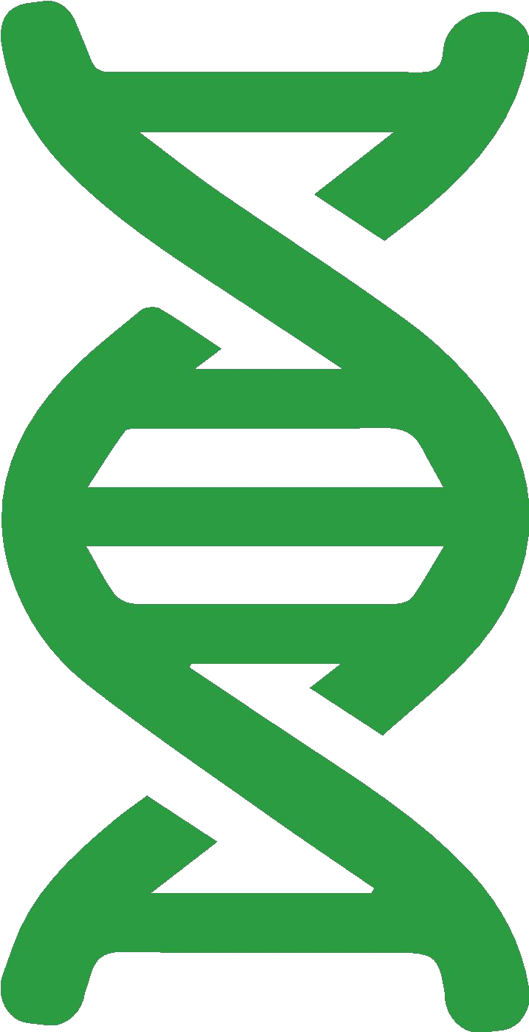
Back-to-School Considerations

Vignette:
Use the Reflection Questions or Big Questions to guide a discussion with peers about this vignette.

Mr. Mireles teaches 8th grade. He usually begins planning for the school year by reviewing assessment data from the previous year. When his students were out of the building for a quarter last year, his district did not give the usual year-end summative science assessment. Mr. Mireles wants to adjust assessing science learning to inform instruction in meaningful ways using the school’s instructional model.
Mr. Mireles meets with fellow teachers to map out a plan using grade-level content and three-dimensional progressions in the standards. They plan to use a variety of assessment strategies for different purposes. To support student agency, they will ask students and families to complete a science interest survey at the beginning of the year. They will use formative probes before each unit and curriculum- embedded assessments to determine where students are in their learning and scaffold in appropriate supports. As much as possible, they will revise or remove assessments that do not provide actionable evidence of student learning.
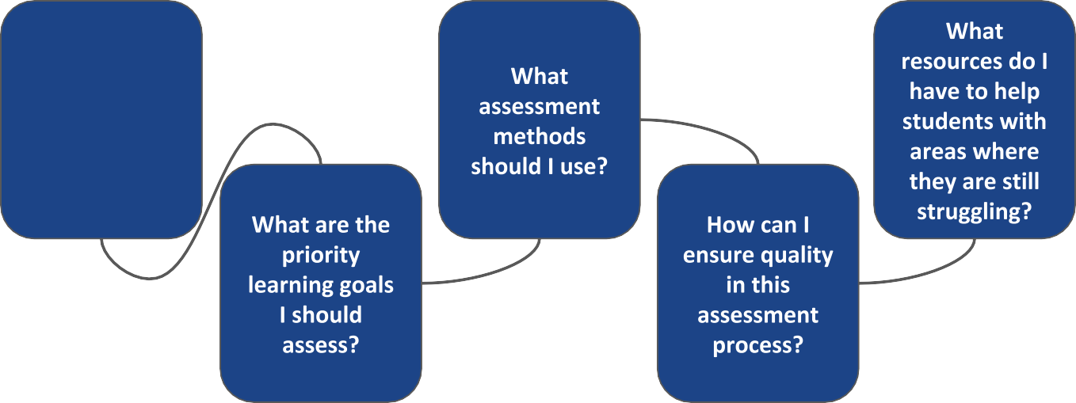
Big Questions for Assessment
What is the rationale for each assessment relative to student learning?

