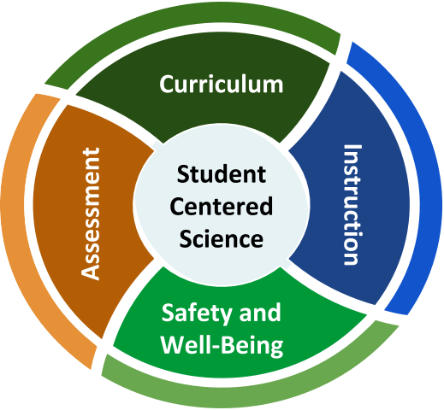
Science

Back-to-School Considerations
Effective instruction in science has students engaged in making sense of the world around them, asking questions, exploring and investigating ideas, and collaboratively creating authentic products that demonstrate standards-based learning. How can that happen as teaching and learning may be restructured?
Tensions We Are Navigating
- There is a need for clear and concrete guidance to move forward with teaching and learning in face-to-face, online, and hybrid modes; however, there is also a call to honor situations that vary across geography and are changing rapidly over time.

- Students, educators, and communities experienced a wide range of learning and life experiences during Quarter 4 of the 2019—2020 school year that impacted them in different ways; however, some are approaching a return to school with a deficit-oriented mindset and an overemphasis on recovery from “loss of learning.”

- Different materials and approaches may be needed to ensure high-quality, equitable science teaching and learning in different modes; however, districts are addressing realities around time, funds, staffing, online access, and physical spaces that may make teacher collaboration, materials adaptation, and purchasing a challenge.

- COVID-19 is a pressing concern for many educators; and, teachers of science also have to address social justice issues that affect the well-being of their communities and confront the ways in which science and engineering have historically exacerbated inequities.
What does effective science teaching and learning look like for possible 2020-2021 back-to-school plans?

Overview
This series of one-pagers addresses four areas for teachers of science, school/district science specialists, and administrators. These resources are designed to empower planning and support decision-making in ways that center students in science teaching and learning.
Curriculum — How should schools decide what needs to be taught in science while adapting to different modes of learning?
Assessment — How will we know what students know and can do when going back-to-school with different models?

Instruction — How can teachers continue high-quality science instruction through different modes of teaching and learning?
Safety and Well-Being — What are the unique needs for student safety and well-being in science teaching and learning?

Science 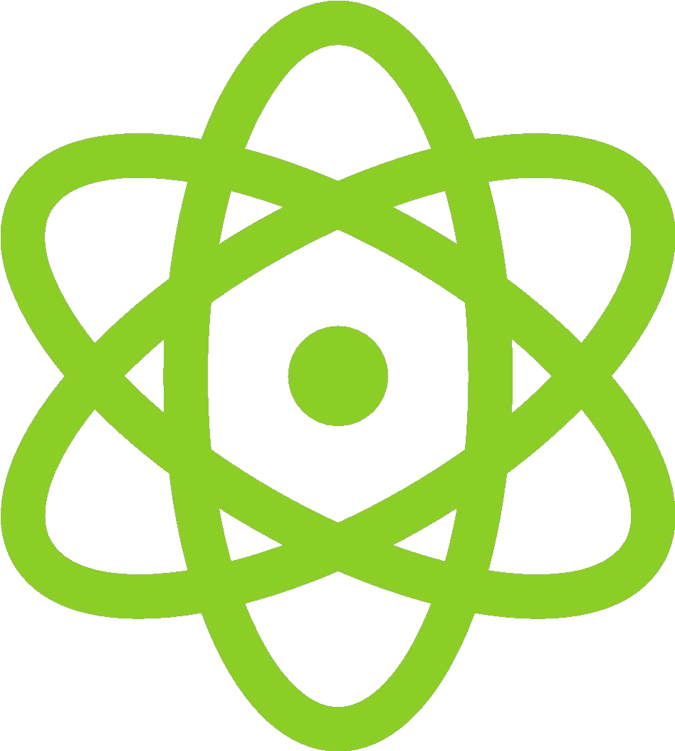 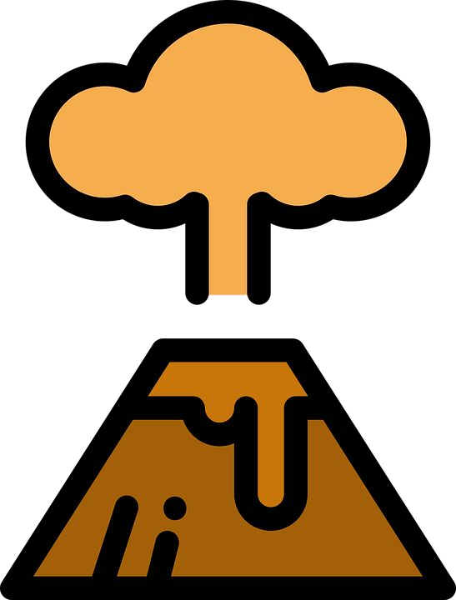 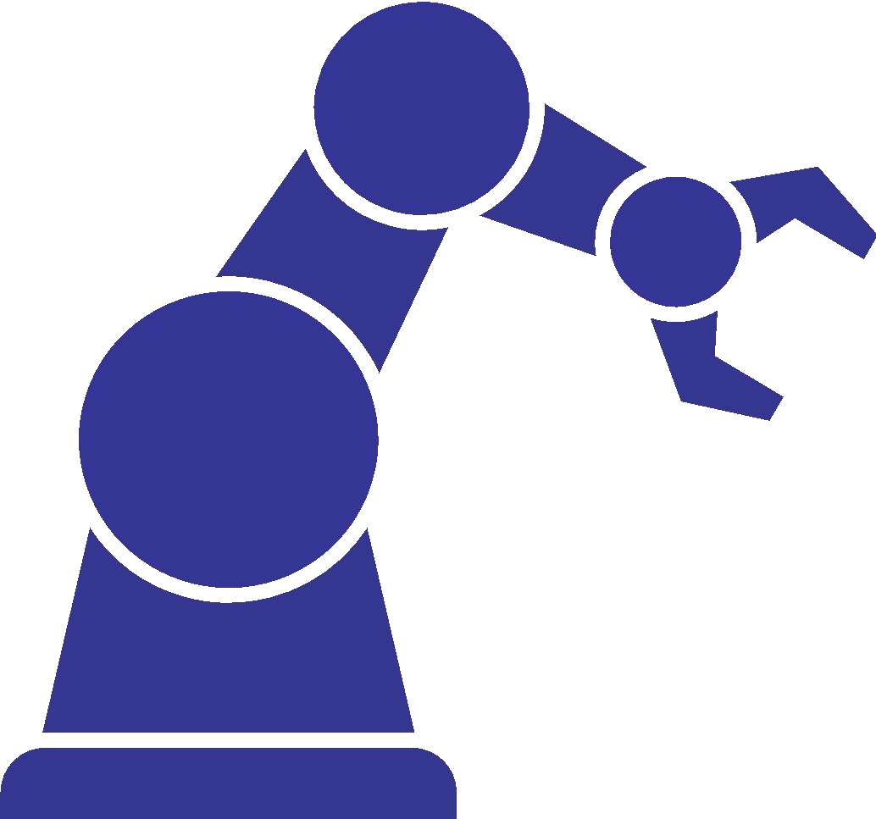
Back-to-School Considerations

Recommended Reflection Questions
Use these questions with your PLC to examine current practice and engage in forward planning.
- What will we need to know about our students? How can we tap into or rekindle students’ dreams and aspirations?
- What opportunities are open to make positive transformations and elevate promising practices? What inequitable or ineffective practices can be transformed or discarded?
- How will you support communities that have been disproportionately impacted by the pandemic?
- What routines and structures do you have in place for science curriculum, instruction, assessment, and social-emotional learning that can be adapted for the current context?
- How can you and your school team build policies and protocols that are responsive when new challenges arise?
Where can we start?
Policy Corner
Keep your eye on the following for policy updates:
- United States Department of Education
- Your state, district, school, and board of education
- Council of Chief State School Officers
- Education Commission of the States
- Johns Hopkins University eSchooI+ Initiative
- Lawrence Hall of Science
- Learning Forward
- National Academies of Sciences, Engineering, and Medicine Reopening K—12 Schools
- National Association of State Boards of Education
- National Governors Association Education
- School Superintendents Association
- Southern Regional Education Board
- Council of State Science Supervisors
- National Science Education Leadership Association
- National Science Teaching Association

Administrators
The Framework for K—12 Science Education establishes a vision of science for all students, with a goal of developing a scientifically literate society and preparing students with the skills, habits and understanding to be college, community, and career ready.
★ Speaking Up for Science and
Social Studies
★ Elementary Science: Equipping Students Through Inquiry and Integration
★ NGSS Appendix: College and
Career Readiness

Teachers
Equity goes beyond access and representation. It means honoring the cultures of our students, accommodating the histories of past and present traumas, providing the necessary resources and rigor, and helping students be a determining factor in forwarding their own learning goals.
★ Toward More Equitable Learning in Science
★ Equity STEM Teaching Tools
★ Kids Speak Out on Student Engagement
★ NGS Navigators

Students, Families, and Communities Families are more engaged by high, clear, and consistent expectations from all educators. Scientific literacy is essential for community decision making & policy.
★ NGSS Parent Guides
★ NSTA Science Resources for Parents
★ Parent’s Science Class
★ CCSSO Parent and Community Engagement

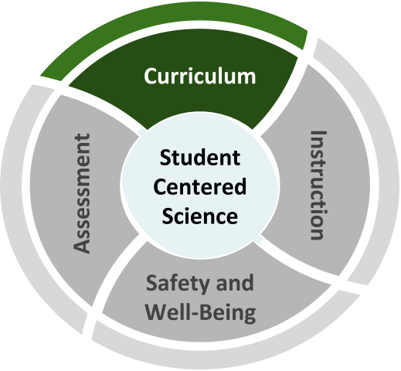
Science Curriculum
Back-to-School Considerations
How should schools decide what needs to be taught in science while adapting to different modes of learning?
Schools need to decide how to address science standards in a way that prioritizes equity and grade-level learning. Science practices, crosscutting concepts, and disciplinary core ideas build over time; sequences and materials need to be adapted accordingly.
Tensions We Are Navigating

- Teachers may be asked to provide remediation or re-teaching; however, students will start the school year with a diversity of skills, knowledge, and wonderings about the world that can be honored through “just-in-time” supplementation and adjustments (see vignette on next page).

  - Many elementary teachers are being directed to focus on math and ELA; however, science is a critical part of a well-rounded education for all students.
Science must not be crowded out of the curriculum.

  - Equity requires meeting the needs of all students, including those whose needs are often underserved, through multiple modes of learning; however, high-quality materials aligned to the pedagogical vision of the Framework for K—12 Science Education are not widely available or in use, especially in multiple formats.

  - Teachers need time to collaborate and plan, both within and between grade levels; however, time is stretched thin and teachers may be on different schedules, which may make finding common times difficult.

Recommended Reflection Questions
Use these questions with your PLC to examine current practice and engage in forward planning.
  - How will you ensure equitable access to on-grade learning? What practices or tools can you use to review curriculum and remove extraneous material that is not on grade-level, e.g. favorite activities or textbook chapters that are not standards-aligned?
  - Do existing resources prioritize student
sense-making using the three dimensions rather than discrete content? If materials unnecessarily focus on skill attainment in isolation (e.g. teaching metric system or scientific method), can these skills be developed in more meaningful ways?
  - How can existing materials be adapted for various learning scenarios in ways that do not disadvantage any students?

Science Curriculum
Where can we start?
Administrators
Support teachers to collaborate, plan, and adjust on a regular basis. Understand the unique needs of science teaching and learning, including time, space, and resources.
★ Stem Teaching Tool for Administrators
★ Highlights from 2018 National Survey of Science and Mathematics Education
★ Science Instructional Materials that Support At-Home Learning

Teachers
Keep science teaching and learning coherent, by considering bundling standards and storylining. Address requisite skills and knowledge in ways that are focused on
grade-level learning.
★ Next Generation Science Storylines
★ Bundling the NGSS
★ Supporting Students in Meaningful Engagement Through NGSS Storylines

Students, Families, and Communities Support student science learning at home by making connections to topics and activities that are meaningful to you.
★ Advice for Families (translations)
★ Advice for Students (translations)

Back-to-School Considerations

Vignette: “Just-in-time” Supplementation
Use the Reflection Questions or Big Questions to guide a discussion with peers about this vignette.

Ms. Kim teaches 5th grade. Learning-from-home assignments in the spring focused on mathematics and ELA. Ms. Kim wants to focus on grade-level learning, and adjust her curriculum map without spending time on disconnected assessments at the beginning of the year.

To help adjust her plans, Ms. Kim reaches out to #NGSSchat to ask for ideas about how the practices, crosscutting concepts, and core ideas connect between 4th and 5th grade. Her 5th grade team also collaborates with the 4th grade team.

The 5th grade team initially focuses on a 5th grade ecosystems unit, integrating some pieces from a 4th grade unit on energy to scaffold toward using models to describe that that energy in animals’ food was once energy from the sun. Ms. Kim adjusts her pacing guide to spend additional time supporting her students with the practice of constructing explanations.
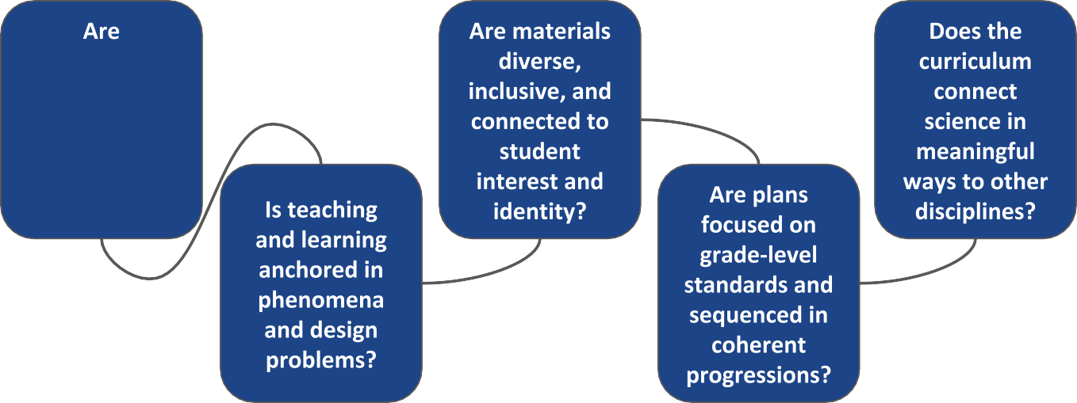
Big Questions for Curriculum

curriculum maps and curricular materials three- dimensional?

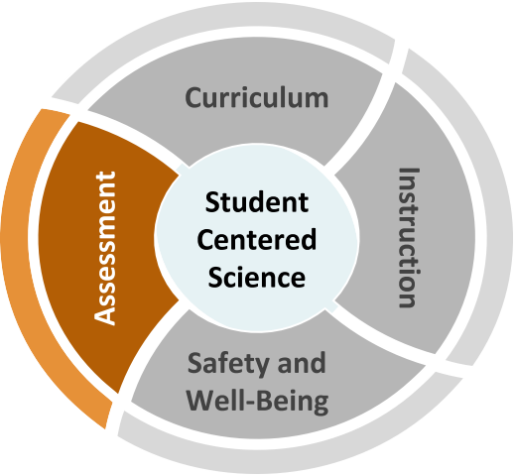
Science Assessment
Back-to-School Considerations
How will we know what students know and can do when going back-to-school with different models?

Schools need to decide what role formative practices and tasks, interim measures, and summative checks play in seamlessly revealing evidence of student progress of 3D learning along a continuum.
Tensions We Are Navigating
- Assessments can provide evidence of student learning; however, students must feel comfortable and safe sharing their work, skills, and knowledge. Create asset-based and identity-safe systems that support students in being comfortable sharing the evidence of their learning fully and in rich detail.

- There are calls for diagnosing student understanding through immediate, extensive, and standardized-type testing; however, assessments should be an integrated part of classroom teaching and learning with the goal of supporting the development of
grade-level practices and concepts (see vignette on next page).
- Teachers use classroom assessment practices that promote ongoing conversations about learning, and provide students with actionable steps to grow agency and ownership of learning; however, teachers may need support in adapting these strategies for online or blended learning.

- Organizations such as Boards of Education and legislatures are calling for data; however, such data may not serve student learning and many assessments privilege only one way of knowing that is not representative of all that students know and can do.

Recommended Reflection Questions
Use these questions with your PLC to examine current practice and engage in forward planning.

    - How will you use formative assessments to understand student skills and knowledge, inform instruction, and scaffold learning opportunities? How will you use assessments to inform equitable access to on-grade learning?
    - What assessment practices can be discarded, particularly those that do not inform learning? How can mandatory assessments be meaningfully implemented and interpreted without “teaching to the test”?
    - How might evidence of learning collected differ for face-to-face, blended, or online learning? What instructional resources can support student learning in these modes, depending on where you determine more focus is needed?

Science Assessment
Where can we start?
Administrators
Collaborate to identify priority three- dimensional learning goals and how assessments support these goals. Revise assessments that are convenient (e.g. multiple choice) but are not three-dimensional.
★ Why Formative Assessments Matter
★ Helping Students Understand What a Test Is and Is Not
★ Science Assessment Task Screeners
★ CCSSO Assessment Considerations

Teachers
Utilize a coherent system of assessment to gauge science learning and student agency. Scaffold formative assessments to support students in making their ideas explicit as they develop higher-level explanations
★ Steps to designing a 3D Assessment
★ Using 3D Interim Assessments
★ What Can I Learn from Students’ Work?

Students, Families, and Communities Encourage students to engage and share at home in meaningful and authentic ways.
★ Learning in Places
★ Science: It’s a Family Affair

Back-to-School Considerations

Vignette:
Use the Reflection Questions or Big Questions to guide a discussion with peers about this vignette.

Mr. Mireles teaches 8th grade. He usually begins planning for the school year by reviewing assessment data from the previous year. When his students were out of the building for a quarter last year, his district did not give the usual year-end summative science assessment. Mr. Mireles wants to adjust assessing science learning to inform instruction in meaningful ways using the school’s instructional model.
Mr. Mireles meets with fellow teachers to map out a plan using grade-level content and three-dimensional progressions in the standards. They plan to use a variety of assessment strategies for different purposes. To support student agency, they will ask students and families to complete a science interest survey at the beginning of the year. They will use formative probes before each unit and curriculum- embedded assessments to determine where students are in their learning and scaffold in appropriate supports. As much as possible, they will revise or remove assessments that do not provide actionable evidence of student learning.
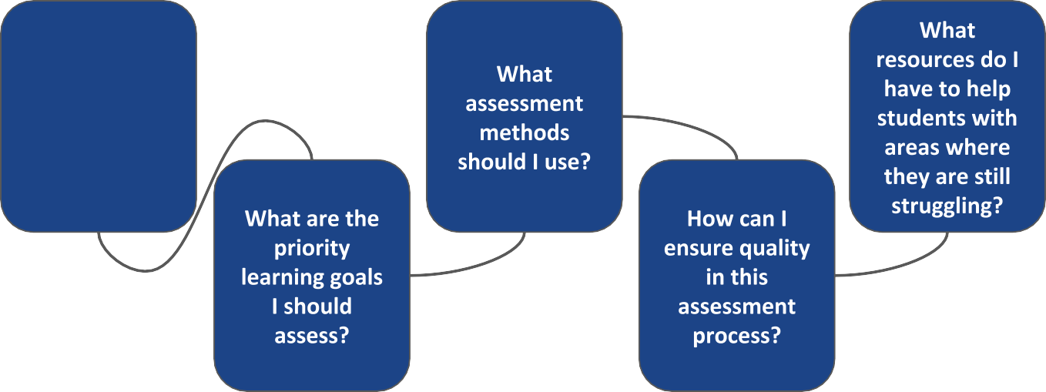
Big Questions for Assessment
What is the rationale for each assessment relative to student learning?

Science Instruction
Back-to-School Considerations
Science learning should be student-centered and consistently engage students in the practices of science and engineering. Instruction should facilitate collaborative sensemaking — a critical component of understanding phenomena and solving problems —
How can teachers continue high quality science instruction through different modes of teaching and learning?
in ways that honor student interest and identity.
Tensions We Are Navigating
- Students learn best when they engage in the practices of science and engineering; however, it may seem “easier” to use lectures, readings, quizzes, and memorization, which do not provide students sufficient opportunity to make sense of phenomena and solve problems.

- Teachers have implemented instructional strategies to provide high-quality, three- dimensional learning; however, converting to remote learning requires different tools and approaches. Teachers of science want to learn how to use tools for adapting science instruction, not just for general use (see vignette on following page).

- This is a moment of opportunity to redesign or replace learning activities that are not standards-aligned in order to create time and space for meaningful student engagement; however teachers need time and professional learning to adapt instruction.

- Schools may be familiar with inclusive practices for instruction, such as universal design for learning; however, adapting options for engagement, representation, and action in digital settings may present barriers to accessibility.
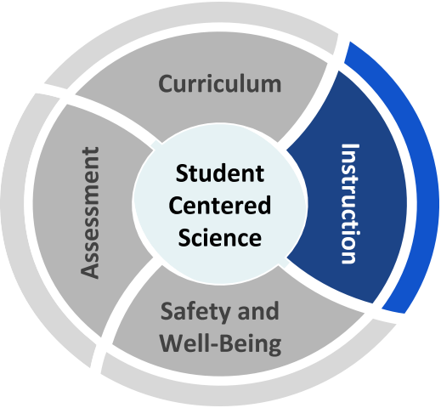

Recommended Reflection Questions
Use these questions with your PLC to examine current practice and engage in forward planning.

- What powerful instructional practices center students as sensemakers and co-constructors of knowledge and skills? How can these practices be adapted for different learning environments?
- What instructional practices might be reconsidered as ineffective or not aligned to a three-dimensional vision of science teaching and learning, e.g. busy work, rote memorization, vocabulary pre-teaching?
- How will you promote student engagement when modes of delivery are different than students may be used to or may change over time (e.g. rotating schedules, sudden return to online learning)?
- Which students are and are not being served in different modes of delivery? Whose interests are being centered?

Science Instruction
Where can we start?
Administrators
Understand the unique needs of science teaching and learning, and ensure that science is included in discussions and decision-making.
★ NGSS Overview for Principals
★ Science Practices Supervision Tools
★ K—8 Science During COVID (WestEd)
★ SREB Online, Blended, and Hybrid Instruction

Teachers
Adhere to a three-dimensional vision of science teaching and learning through purposeful selection of teaching strategies and technology tools.
★ OpenSciEd Remote Teaching
★ Role of E-Learning in Science Education
★ Designing Productive Uncertainty into Investigations
★ Adapting Science for Distance Learning
Students, Families, and Communities
Connect to high-leverage science teaching and learning practices, such as phenomena, science notebooks, and science talk.
★ Phenomena
★ Science Talk Moves
★ Science Notebooks

Back-to-School Considerations

Vignette: Tools and Approaches for Instruction
Use the Reflection Questions or Big Questions to guide a discussion with peers about this vignette.
Mr. Lee teaches high school biology and chemistry to mixed-grade classes. In face-to-face instruction, Mr. Lee’s students consistently engage in conducting investigations to gather data, reasoning through small group discussions using talk protocols and whiteboard modeling, and communicating in pairs, quads, and full class discussion, as well as individual writing.
In Mr. Lee’s district, blended learning will have students on different tracks alternating face-to-face and remote learning. Mr. Lee and his department use the SAMR model to select technologies to facilitate discussion and sensemaking for students with varying access to technology.
Mr. Lee plans to use technology on face-to-face days for several purposes. Some labs that cannot be safely modified will be replaced by simulations or micro- scale demonstrations that can be projected. Mr. Lee also plans to use document editing and video to allow students on opposite tracks to work together.
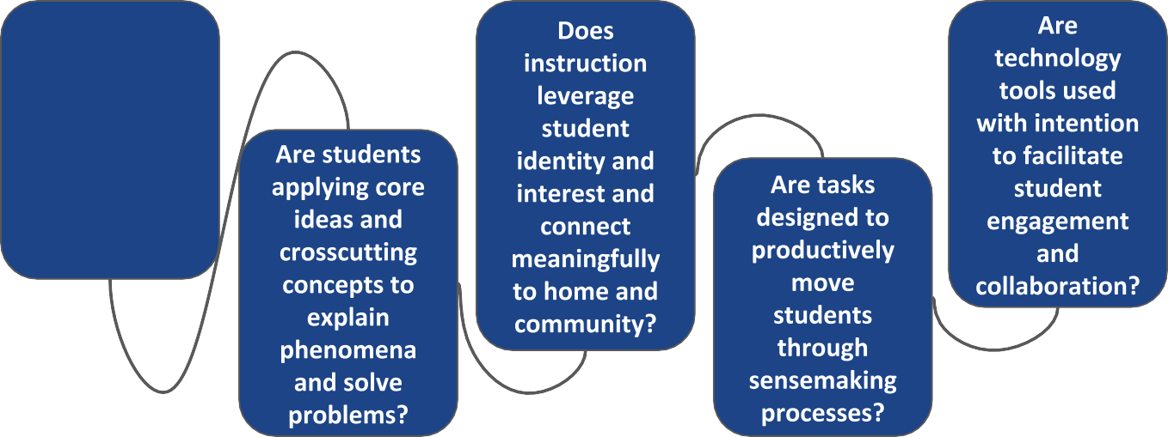
Big Questions for Instruction

Are students engaging in scientific and engineering practices?

Safety and Well-Being In Science Back-to-School Considerations
What are the unique needs for student safety and well-being in science teaching and learning?
School closures, hybrid instruction, and school reopening have impacted teaching and learning across all content areas. Science has unique safety needs associated with face-to-face instruction related to investigation and discourse. Social-emotional
well-being also must be addressed.
Tensions We Are Navigating
- Communities have been impacted to varying degrees; and educators must recognize the disproportionate impact of COVID-19 on Pacific Islander, Black, American Indian/Alaska Native, and Latino/a/x communities; students with disabilities; and those in poverty.

- Safety is always a high priority in science, including the appropriate use of safety equipment; however, activities may need to be modified to adhere including physical distancing, additional personal protective equipment, and cleaning protocols.

- Collaboration and discourse are at the heart of student-centered science learning; however, face-to-face interactions need to accommodate health guidelines established by the district; online interactions may need additional supports to establish safe spaces for discussion.
- Social-emotional connections are critical to fostering sensemaking; however, creating and supporting relationships requires different structures in online environments.
- Student safety and well-being is a priority; and adults, including staff and families, must be also be supported.
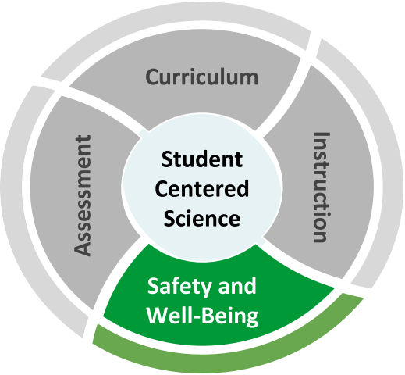

Recommended Reflection Questions
Use these questions with your PLC to examine current practice and engage in forward planning.
- Are there science topics that may need to be addressed differently or with additional care in light of the effects of the coronavirus in your community? How will you respectfully address the range of student experiences?
- What are the unique needs for science planning, instruction, classroom space, equipment/supplies, etc. with regard to student safety and well-being?
- What are the opportunities to leverage technology in powerful ways and to make connections to student health and social-emotional learning?
- Are resources for safe and supportive science teaching and learning accessible to all students? Are expectations clear for all teachers and families?

Safety and Well-Being In Science
Where can we start?
Administrators
Ensure that all aspects of safety are attended to for teachers and students. Understand the physical safety needs of face-to-face instruction and the complexities of interweaving SEL supports into science.
★ CDC School Guidance
★ SEL to Support Students and Families
★ The New Routines for Students When Schools Reopen
★ National Academies: Reducing
Transmission When Schools Are Open
★ Duty of Care in Science
Teachers
Maintain fidelity to district practices around safety and well-being in science.
★ safety Considerations for Science Investigation and Engineering Design
★ NSTA Safety Portal
★ CASEL CARES SEL Resources
Students, Families, and Communities
Stay up to date on the latest communications from your school district. Keep asking questions!
★ Practicing Safe Science at Home
★ Supporting Families During COVID-19
Back-to-School Considerations

Safety and Well-Being Vignette
Use the Reflection Questions or Big Questions to guide a discussion with peers about this vignette.

Dr. Reppuhn is a district STEM specialist who runs district Science/STEM PLN meetings. Teachers have asked her how to include coronavirus in science lessons. Some teachers are excited to use a timely phenomenon, but some are concerned that many students’ families have been impacted by the pandemic.

This year, Dr. Reppuhn reached out to her colleagues in School Counseling and Health Education for advice and input. They developed a list of considerations for addressing the pandemic in scientifically accurate ways that attend to students’ mental and emotional
well-being. They will share the list in a PLN meeting, and offer support to schools upon request.

Dr. Reppuhn also created a resource page for her district science website. She includes links to state, district, and federal guidance for health and safety for face-to-face and online modes of learning.
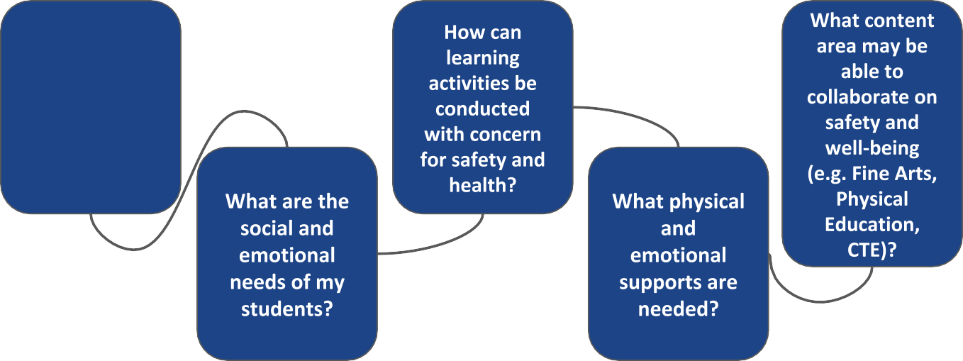
Big Questions for Safety and Well-Being

What are the science learning goals that need to be met?

